**CICD PIPELINE**

* It is continuous integration and continuous delivery
* CI develop the package and CD deploy it
* 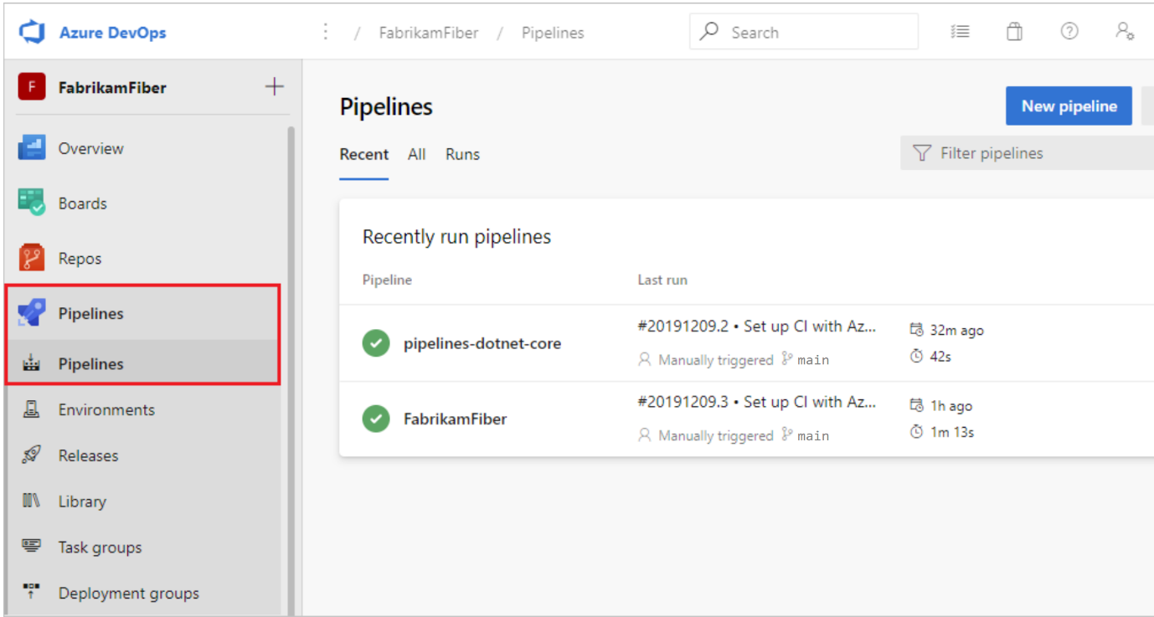
* **Azure Pipelines benefits**:
* ff Azure Pipelines provides a quick, easy, and safe way to automate building your projects with consistent and quality code that's readily available to users.
* Azure Pipelines offers the following benefits:
* Works with any language or platform.
* Deploys to different types of targets at the same time.
* Integrates with Azure deployments.
* Builds on Windows, Linux, or Mac machines.
* Integrates with GitHub.
* Works with open-source projects.

**Continuous integration:**

Continuous integration (CI) is a practice development teams use to automate merging and testing code. CI helps to catch bugs early in the development cycle, making them less expensive to fix.

To ensure quality, Azure Pipelines executes automated tests as part of the CI process. Azure Pipelines CI systems produce artifacts and feed them to release processes to drive continuous deployments.

**Continuous delivery**

Continuous delivery (CD) is the process of building, testing, and deploying code to one or more test or production environments. Deploying and testing in multiple environments optimizes quality.

Azure Pipelines CD systems produce deployable artifacts, including infrastructure and apps. Automated release processes consume these artifacts to release new versions and fixes to existing systems. Systems that continually monitor and send alerts drive visibility into the CD process.

# PIPElINE creation in azure devops:

